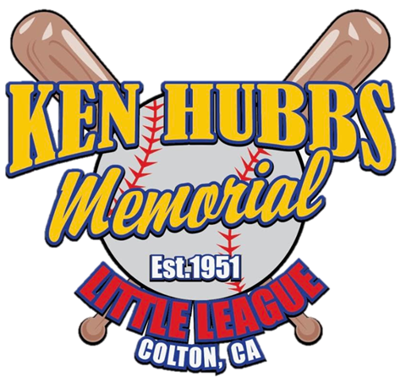

KEN HUBBS MEMORIAL LITTLE LEAGUE
COLTON, CA 92324
LEAGUE# 405-21-13
CALIFORNIA DISTRICT 21

LEAGUE PRESIDENT: ADRIAN VELLANOWETH JR
SAFETY OFFICER: LARRY WHITEMAN

2020 LEAGUE ASAP PLAN

IMPORTANCE OF SAFETY

The purpose of this document is to emphasize the importance of safety at Ken Hubbs Memorial Little League and to identify important safety issues of which all individuals involved should be aware.

League officers, coaches, parents and players will take safety issues very seriously.

This safety plan is qualified by the ASAP program. The safety plan herein refers to play at Max Lofy Field located at 351 E. E Street Colton, CA, Veterans Field located at 290 E, O Street Colton, CA 92324, Colton Middle School located at 670 W. Laurel Street Colton,CA 92324 and Lincoln Elementary School located at 444 E. Olive Street Colton, CA 92324 . Further information beyond this document regarding safety and the ASAP program is available by contacting the Ken Hubbs Memorial Little League Safety Officer listed below.

There are several points addressed in this document that are required for an approved ASAP compliant Safety Plan. The following is a list of the important features, policies, and requirements of the Safety Plan:

1. Safety Officer:
The Ken Hubbs Memorial Little League program has an active Safety Officer on file with Little League Headquarters. This Safety Officer for the 2020 season is:

Larry Whiteman
P.O Box 802
Colton CA, 92324
909-379-3865 (cell)

Any questions regarding this plan and Ken Hubbs Memorial Little League safety can be directed to the Safety Officer or the 2020 League President:

Adrian Vellanoweth Jr.
P.O Box 802
Colton, CA
909-503-6002 (cell)

2. Safety Plan:

This document has been developed by Ken Hubbs Memorial Little League to provide an overview of the procedures, policies, and activities that have been instituted by the League to provide a safe and healthy environment for those participating in our Little League Baseball and Softball programs. As part of maintaining awareness of the importance of safety, this document will be printed and distributed to all league officials and volunteers active during the season.
It will also be posted on the Ken Hubbs Memorial Little League website for reference by all volunteers, players, and parents participating in Ken Hubbs Memorial Little League. A copy will also be available in the Snack Bar at Max Lofy Field and Veterans Field. This plan will also be submitted to the District Administrator

Emergency Information:

The emergency contact information sheet which also contains contact information for league officers and coordinators will be included as part of the Safety Plan that is distributed to volunteers as outlined above. Also provided with the contact information are Emergency Contact Procedures to assist in the event of an emergency situation.

This emergency information will be posted at the Snack Bars located at Max Lofy and Veterans Fields for reference.

3. Background Checks for Volunteers:

Managers, coaches, board members and any others, volunteers or hired workers, who provide regular services to Ken Hubbs Memorial Little League and/or have repetitive access to or contact with players or teams are required to fill out a 2020 Little League Volunteer Application. Based on the volunteer application, Ken Hubbs Memorial Little League will conduct a nationwide background check including available sex offender registries.

Anyone refusing to fill out the Volunteer Application is automatically ineligible to be a league volunteer or member in any capacity. A copy of these forms and instructions are included within the appendix.

4. Fundamentals Training:

It is the intent of Ken Hubbs Memorial Little League that all managers, coaches, and assistant coaches attend and participate in at least one fundamental coaches training session. The minimum requirement is for at least one member of the coaching staff for each team to attend one of the training sessions being offered. We will be offering this formal training as part of a regional clinic

Coaching Fundamentals Training:

Mandatory Coaches Clinic
Held on March 14th 2020
At Max Lofy Field

5. First Aid Training:

Ken Hubbs Memorial Little League intent is for all managers, coaches, and assistant coaches to attend a first aid training session prior to the start of the spring season. This training includes CPR familiarity. The minimum requirement is for every manager or coach to attend a First Aid Training session once every three years with at least one team representative in attendance every year. To accomplish this goal, we will be offering First Aid Training for the 2020 Season:

Location: Max Lofy Field, Time be to Be Announced

Volunteers will be notified when the details of the local training session are final.

All administrators, managers and coaches are required to take and complete a concussion training course. This mandatory training is to be completed prior to holding any practices or games with our players.

The link to our concussion training information is here:
https://www.cdc.gov/headsup/youthsports

Please contact Larry Whiteman, Ken Hubbs Memorial Little League Safety Officer, with questions.

6. Field Inspections:

The City of Colton Parks & Recreation Department inspects the fields every year at the beginning of the season for exposed fence wires, dugout conditions, benches, etc. The fields and surrounding areas are also reviewed on a regular basis during the season by the Safety Officer and/or other Board Members. In addition, Ken Hubbs Memorial Little League team coaches and umpires will be required to review the field on which they will be playing before each game to look for and correct any unsafe conditions (holes, broken glass, rocks, equipment, etc.) prior to the start of play. Please refer to the checklist in the appendix section of this document.

Any field or areas used for league practices shall be inspected for unsafe conditions by team coaches prior to all league practices as well.

7. Facility Survey:

Ken Hubbs Memorial Little League conducts a formal Facility Survey that is updated on an annual basis and submitted to the Little League Headquarters along with this Safety Plan. You may contact the league Safety Officer or other league officials for a copy or access if necessary.

8. Concession Stand Procedures:

Ken Hubbs Memorial Little League operates a small concession stand in front of the field at Max Lofy and on the lower level at Veterans Field. These concession stands (referred to as the “Snack Bar”) consist primarily of pre-packaged food, drinks, and snacks. There is also a small outdoor grill that is used for preparation of hot dogs and hamburgers.

Volunteers who operate the concession stand will be provided with instructions by the Snack Bar Manager and given copies of the Ken Hubbs Memorial Little League Concession Policy. This policy is included within the appendix of the Safety Plan for reference.

9. Equipment Inspection:

Regular inspection of equipment is necessary to ensure safety. Replacement of defective equipment must be done immediately by contacting the Equipment Manager or any league official. Equipment checks are done formally by three sources:

1) By the equipment manager at the beginning of the season and periodically throughout the year.
2) By coaches at the beginning of each game and
3) Umpires during the course of games.

10. Accident Reporting and Tracking:

An incident that causes any player, manager, coach, umpire, or volunteer to receive medical treatment and/or first aid must be reported to the league Safety Officer within 48 hours of incident. This includes even passive treatments such as the evaluation and diagnosis of the extent of the injury or periods of rest. The league Safety Officer will log all reported incidents and track as noted below.

How to Make a Report:

The League will provide hard copy printouts of the Incident / Injury Tracking Report (included in the appendix) with all First Aid kits that are provided to every Team as part of the standard issue equipment. This will allow teams to have the form with them when traveling to other towns. In addition, copies of this form will be kept in the concession stand at Max Lofy and Veterans Fields. These forms are also located on our Ken Hubbs Memorial website.

A coach or league official must complete an incident/injury tracking report as soon as possible after the incident occurs and notify the league Safety Officer via telephone or email of the incident. The coach or official may either deliver the form to the Safety Officer or leave the form in the Snack bar in a location designated in advance by the Safety Officer so that he can receive this information in a timely manner.
Within 2 days following the incident, the Safety Officer will contact the injured party or the party’s parents and:
(1) Verify the information received.
(2) Obtain any other information deemed necessary.
(3) Check on the status of the injured party; and
(4) In the event that the injured party required other medical treatment (i.e., Emergency Room visit, doctor’s visit, etc.) will advise the parent or guardian of the Ken Hubbs Memorial Little League’s insurance coverages and the provisions for submitting any claims.

If the extent of the injuries is more than minor in nature, the Safety Officer shall periodically call the injured party to:
(1) Check on the status of any injuries, and
(2) Determine if any other assistance is necessary in areas such as submission of insurance forms, etc.

The Safety Officer will continue this process until such time as the incident is considered “closed” (i.e., no further claims are expected and/or the individual is participating in the league again). An Accident Notification Form will be generated and sent to Little League Headquarters in Williamsport (Attention: Dan Kirby, Risk Management Department) and reported to the District Safety Officer when required.

All incidents, accidents, and safety violations should be reported to the Safety Officer within 48 hours of the incident. Timely reporting of safety violations is a key factor in promptly dealing with safety issues including preventative measures or corrections that may protect a child from harm in the future.

11. First Aid Kits:

A First-Aid Kit is required to be on hand for every game and practice. Ken Hubbs Memorial Little League supplies each team a First-Aid Kit with the team’s equipment bag. In addition, First-Aid Kits and first aid supplies are located in the concession stand for use as needed. If supplies are depleted during the season, contact the Safety Officer or a league official for replacements.

12. Little League Rules:

Ken Hubbs Memorial Little League Managers, Coaches, Umpires, and League Officials are required to enforce Little League rules at all games and practices, including proper equipment. Most Little League rules have some basis in safety, so it is important to follow them. Below is a list of both Ken Hubbs league rules and key Little League rules pertaining to safety:

FIELD AND DUGOUT SAFETY

It is important to remember that we want to make baseball and Softball a safe and enjoyable experience for all the players. A bulleted list of several of the league policies and key Little League baseball and softball rules regarding field and dugout safety follows.

● A phone list for emergency numbers, non-emergency numbers, and league contact information is posted at Max Lofy and Veterans concession stands (snack Bar). The city of Colton has 911 services for emergencies. It is good practice to identify those coaches and parents who have cell phones available for all games and practices
● A first-aid kit and first aid supplies are located in the Snack Bar at Max Lofy and Veterans Fields. In addition, each team is issued a first aid kit with the team’s equipment bag. If supplies are depleted during the season, contact the Safety Officer or league officials for replacements.
● No games or practices should be held under severe weather conditions (especially lightning) or when field conditions are unsafe. It is important for coaches and officials to be diligent with regard to playing conditions. Always error on the side of caution.
● Follow league policy regarding Lightning Safety.
● The fields and surrounding areas must be inspected on a regular basis. The field will be reviewed before each game by the umpire and team coaches to look for and to correct any unsafe conditions (holes, broken glass, rocks). Any field or areas used for league practices shall be inspected for unsafe conditions by team coaches prior to all league practices and games.
● A Little League Facility Survey is updated annually, submitted to Little League headquarters and kept on file. Contact the Safety Officer or a league official for a copy or access if necessary. ● Only players, managers, coaches and umpires are permitted on the playing field during play and practice sessions.
● All bats and loose equipment must be kept off the playing fields. Bat racks are placed behind screens/fence. Organized equipment can prevent tripping hazards.
● Coaches should establish a procedure for retrieval of foul balls batted out of play. During practice sessions and games, all players should be alert and watching the player at bat on each pitch.
● Coaching staffs, UIC, Safety Officer and umpires are responsible for the regular inspection of equipment. This includes both league equipment and equipment brought by the player. Non-safe equipment must be removed immediately and replaced as soon as needed. Make sure the equipment is properly fitted to the players.
● Ensure players have required equipment at all times, even catchers warming up pitchers.
● All fields are to use bases that disengage from their anchors, as required by Little League.
● Pitching Machines will be maintained in good working order and must be operated only by adult Managers and Coaches.
● “Horseplay” should not be permitted.

PLAYER SAFETY

Ken Hubbs Memorial Little League and Little League key rules pertaining to player safety are outlined below:

● Coaches should inspect equipment on a regular basis, making sure it fits correctly and is in proper working order. Broken or improper equipment can be replaced by contacting the Equipment Manager or league officials. Batting and catching helmets are not permitted when they have been painted by anyone other than the manufacturer.
● Batters must wear protective helmets during practices and games.
● Catchers must wear a catcher’s helmet with face mask and throat guard, chest protector and shin guards.
● Male catchers must wear a long-model chest protector, protective supporter and cup at all times.
● Warm-up catchers must wear catcher’s helmet, facemask, and throat guard 7 while warming up pitchers (skull caps are not permitted). This applies between innings, during bull-pen warm-ups and pre-game infield drills. Adults may NOT warm up a pitcher. This is a safety issue for both the player and the adult.
● Rule 7.08a (sections 3, and 4) is particularly important for safety and will be vigorously enforced. A runner must slide OR avoid a fielder who has the ball and is waiting to make the tag. Except when returning to base, no head-first slides are permitted. If any coach or parent is unsure of the proper interpretation of rule 7.08a please see the Safety Officer or other league officials.
● Coaches shall instruct all players in safe sliding techniques as well as how to avoid a pitched ball.
● Players must not wear watches, rings, pins, jewelry or other metallic items by Little League baseball rule.
● Parents of players that wear glasses should be encouraged to provide “safety glasses”.
● No on-deck batters are allowed. No player should handle a bat even while in an enclosure, until it is his/her turn at bat.
● Players who are ejected, ill or injured should remain under coach supervision until released to the parent or guardian.
● After a game or practice, coaches should not leave the area until all players have been picked up.
● Players will be instructed in proper stretching and general sports health maintenance procedures, including proper throwing, fielding and hitting techniques to limit injury.
● Injuries should be reported immediately per Ken Hubbs Memorial Little League’s “Accident Reporting & Tracking” procedures as outlined in the Safety Plan.

ADULT TRAINING & SAFETY

● All coaches are required to attend a Fundamental Training Clinic at dates/ locations specified earlier in this document. It is required that each manager and coach shall attend at least once every three years with at least one team representative of each team attending every year.
● Periodically, Ken Hubbs Memorial Little League will hold additional coaches training clinics during the season. Contact league officials for more information.
● All umpires are expected to participate in pre-season rules and umpire clinics at the local and/or district level.
● All coaches and umpires should be familiar with Little League and Ken Hubbs Memorial Little League safety, playing rules and procedures. These are distributed to all managers, coaches and umpires at the beginning of the season and are readily available thru league officials or via the concession stands at Max Lofy and Veterans Fields as well as online at the league’s website.
● The Ken Hubbs Memorial Little League shall have a Safety Plan in effect that includes safety policies for its league Concession Stand (Snack Bar). This plan will be reviewed and updated annually.

13. 2020 Qualified Safety Program Registration

Ken Hubbs Memorial Little League has completed a 2020 Qualified Safety Program Registration Form. A copy of this form is located in the Appendix

14. League Registration Data Reporting

Each year, Little League Baseball requests player roster, coach and manager listings be submitted to the Little League Data Center. Ken Hubbs Memorial Little League Baseball has submitted to Little League Data Center, all player, coach and manager listings available as of March 31, 2020. This information will be updated upon completion of registrations for the 2020 season.
Registration Start: December 21, 2019
Registration End: February 22, 2020

15. Submit a qualified safety plan registration form with our ASAP plan.

APPENDIX

A. Emergency / League Contact Information
B. Emergency Contact Procedures
C. Lightning Safety Policy and Brochure
D. Concession Stand Policy
E. Pitching Machines Policies and Procedures
F. Accident Notification Form
G. Background Checks:
H. Facility Survey Confirmation Form
I. 2018 Qualified Safety Program Registration
J. Mandatory Concussion Training Information Flyer

A. KEN HUBBS MEMORIAL LITTLE LEAGUE EMERGENCY PHONE NUMBERS:

In case of emergency
Dial 911
Colton Police | 909-370-5000
Colton Fire | 909-370-5100

2020 KEN HUBBS MEMORIAL LITTLE LEAGUE CONTACTS:
League Phone Number: 909-571-2621
League E-Mail: kenhubbslittleleague1951@gmail.com
www.kenhubbslittleleague.com

NAME | BOARD POSITION | PHONE NUMBER
Adrian Vellanoweth Jr, | President | 909-503-6002
Shilo Sutton | Vice President | 909-486-0226
Cecelia Aboytes | Treasurer | 951-505-7452
Nicole Duenas | Snack Bar Coordinator | 909-669-7343
Larry Whiteman | Safety Officer | 909-379-3865
Lorenzo Reyes | Field Maintenance | 909-252-6643
Karina Rodriguez | Secretary | 951-801-9947
Sonia Ramos | Head of Team Parents | 909-580-0968
John Oloteo | Equipment Manager | 951-505-0587
Gabriela Aguilar | Farm Baseball Coordinator | 909-327-5851
Larry Jimenez | Minor BB/SB Division Coordinator | 909-639-9891
Carlos Garcia | T-ball/Junior B Division Coordinator | 951-533-2637
Trey Aboytes | Major BB/SB Division Coordinator | 951-505-3914

B. Emergency Contact Procedures

The most important help you can provide to a person who is seriously injured is to call for professional medical help. Make the call quickly, preferably from a cell phone near the injured person. If this is not possible, send someone else to make the call from a nearby telephone.

Be sure that you or another caller follows these steps:

1) First dial 9-1-1.
2) Give the dispatcher the necessary information. Answer any questions that they might ask. Most dispatchers will ask:
• The exact location or address of the emergency? Include the town name, nearby intersections, landmarks, etc. as well as the field name and location of the person(s) needing care, if applicable. Our address is: Max Lofy 351 E. E Street Colton, CA 92324 & Veterans Field 290 E. O Street Colton, CA 92324. The telephone number from which the call is being made.
• The caller’s name.
• What happened — i.e., a baseball-related accident, bicycle accident, fire, fall, etc.?
• How many people are involved?
• The condition of the injured person— i.e., unconscious, chest pains, or severe bleeding?
• What help is being given (first aid, CPR, etc.)?
3) Do not hang up until the dispatcher hangs up. The dispatcher may be able to tell you how to best care for the victim.
4) Continue to care for the victim until professional help arrives.
5) Appoint someone to go to the street and look for the ambulance or fire engine and flag them down if necessary. This saves valuable time. Remember, every minute counts.

C. Ken Hubbs Memorial Little League will follow Little League International policy regarding lightning safety with the following guidelines:

1. Watch for developing or approaching storms; use all resources (web, TV, radio, etc.) to determine the risk level.
2. At the first sound of thunder or visible lightning - CLEAR THE FIELD!
A thunderstorm can cast lightning up to 10 miles from the edge of the storm, or about as far as the sound thunder can carry.

WHAT TO DO:
- Go to a large enclosed building, if one is nearby
- Go to metal-top cars, with windows rolled up, if no enclosed building is available
- Complete a check of the facility for anyone still outdoors

WHAT NOT TO DO:
- Don’t allow players to remain in the dugouts or spectators to stay in the stands
- Don’t carry metal items (like bats) or walk beside metal fences
- Don’t go to an open-sided shelter; it is not adequate and should not be used.

3. Wait at least 30 minutes after the last lightning strike/peal of thunder before returning to play
4. Do not leave the facility until directed; wait at designated location(s) at the field until the game is postponed or cancelled.
5. Make sure all players are accounted for and leaving with approved person(s)

If someone is struck by lightning:
✓ Lightning victims do not carry an electrical charge, are safe to handle, and need immediate medical attention.
✓ Call for help. Have someone call 9-1-1 or your local ambulance service.
✓ Give first aid. Begin CPR if necessary.
✓ If possible, move the victim to a safer place.

For more information on lightning safety, visit NOAA’s
.

Parents, coaches, umpires and all volunteers - please help enforce this policy. Our kids’ lives may depend on you!

D. CONCESSION STAND POLICY

KEN HUBBS MEMORIAL LITTLE LEAGUE 2020

1. Adult supervision must be in effect at all times.
2. Only adults are allowed to operate or be near the grill.
3. Outdoor grills will be placed in an area away from spectators.
4. All volunteers will wash their hands on a regular basis. (Hand Sanitizer available)
5. Unwrapped food must be handled with plastic gloves, paper towels or plastic wrap.
6. No glass containers of any type will be sold at the concession stand.
7. Everything must be cleaned up and put away at the end of each shift.
8. A complete First-aid Kit will be kept in the concession stand.
9. A fire extinguisher shall be kept in the concession stand for emergency use.
10. A list of emergency phone numbers will be posted in the concession stand.

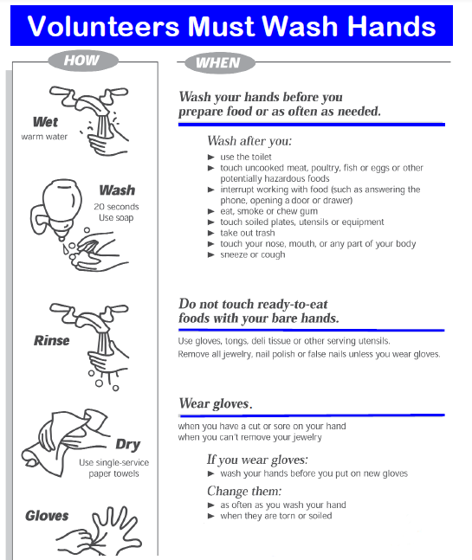

E. PITCHING MACHINE POLICIES AND PROCEDURES

The batting cages are located behind the playing field at Max Lofy Field. Coaches are to follow the policies and procedures listed below when using the pitching machines.

General Pitching Machine Use:
- Pitching Machines are to be set-up and operated by adults / coaches only. This includes feeding the machines and making adjustments.
- All batters must wear a protective helmet when in the cage. This includes the soft toss areas.
- All players not participating must remain outside of the cage.

F. Accident Notification Form:
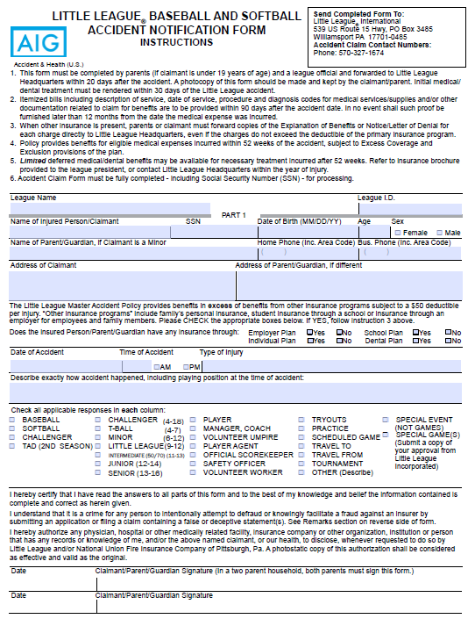

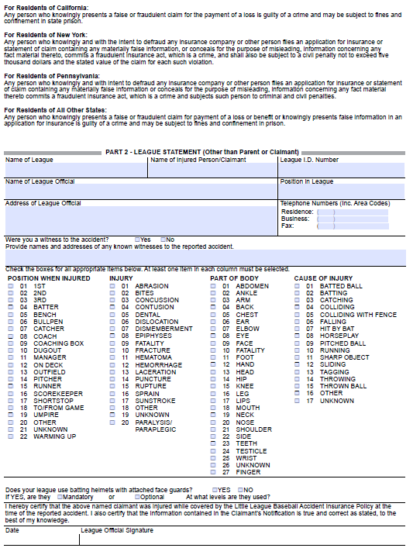

G. VOLUNTEER APPLICATION AND BACKGROUND CHECK FORMS

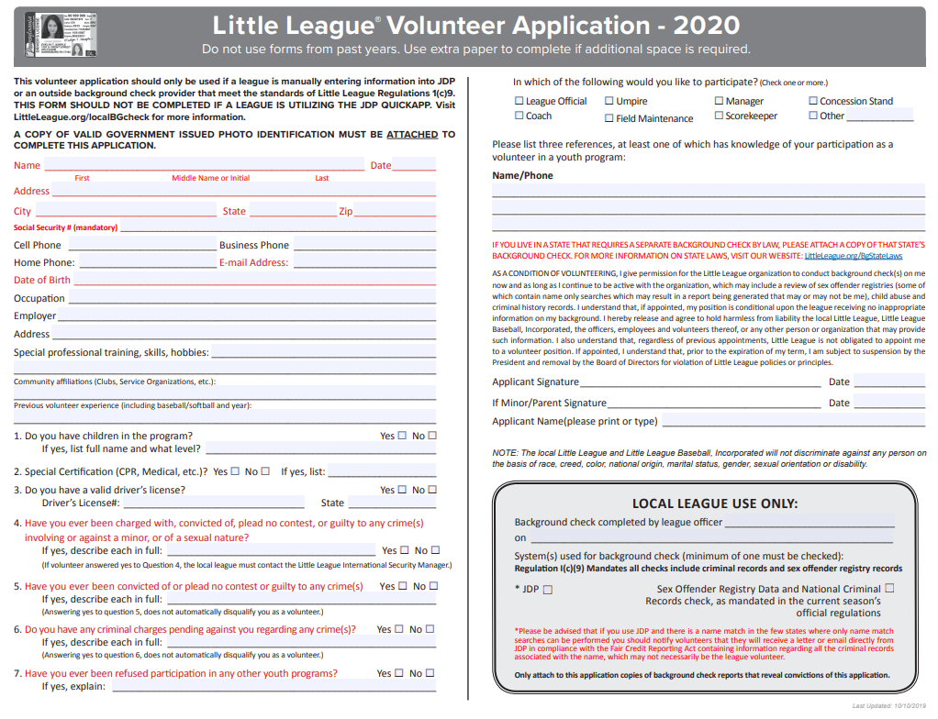

CORE INSTRUCTIONS:
All volunteers involved at Ken Hubbs Memorial Little League are required to provide information to conduct criminal background checks.

Managers, coaches, board members and any others, volunteers or hired workers, who provide regular services to Ken Hubbs Memorial Little League and/or have repetitive access to or contact with players or teams are required to fill out the attached 2020 Little League Volunteer Application form. You must include your social security number on the form where requested. Please be sure to sign both forms.

Please return form to the league’s compliance officer who will be responsible for conducting the background checks:
Shilo Sutton
Vice President

The information you provide and the results of your criminal background check will be kept in a secure location under lock and key at all times. It is your right to request to see the results of the background check. If you would like to see the results, please make a request in writing to Adrian Vellanoweth, League President.

It is recommended you keep a copy of these forms for your records.

If you have any questions, please contact Adrian Vellanoweth at kenhubbslittleleague1951@gmail.com

**Please note that, per Little League National requirements, anyone who does not complete these forms is automatically ineligible to be a league volunteer or member.

H. Facility Survey Confirmation Form See online Data Center
I. 2020 Qualified Safety Program Registration See online Data Center
J. Mandatory Concussion Training Information Flyer

ATTENTION ALL MANAGERS AND COACHES

Before you can take the field, you must take the mandatory concussion and head injury training!
Please do so ASAP! THANK YOU!

1. CA Laws requiring the mandatory training: http://www.littleleague.org/learn/ programs/childprotection/concussions/ ConcussionsCalifornia.htm

2. Link for the Heads-Up Concussion training:
https://www.cdc.gov/headsup/youthsports

Once on this link, a manager or coach can create a sign in, take the course and print out their certificate. *Please note that if a manager or coach has previously taken the course (through AYSO or another organization) they can just submit a copy of their concussion training certificate.

3. Submit your training certificate to the Safety Officer or any board member.
Thank you for protecting our youth!

